Documents for meeting to be held on 20th January 2026
Agenda item 172.25 – Minutes for the last meeting (16.12.2025) can be found on the Minute page of the website.
_____________________________________________________________________________
Agenda item 175.25.04 – Response from Head of Commercial NYC
Thank you for your email to Tom Ireland in relation to the sale of three small parcels of land at Heath Crescent in Bradley. I have responded to each of your questions below:

- Heath Crescent was carefully designed and laid out in the last century with broad verges on either side of the road. That was one of the reasons why those verges now form one of the Local Green Spaces in the Bradleys Both Neighbourhood Development Plan. NYC's proposal to sell off those verges piecemeal means that there is a very real danger that they will no longer be preserved in the way intended by the original designers and by the NDP. In particular, there is a real danger the verges will be converted, again piecemeal, to form hard-surfaced parking spaces.
Craven District Council had previously granted one of the residents a permanent easement for land in front of their home and a driveway was constructed. This easement cannot be revoked and provides all that is needed for its use as a driveway. The resident made an offer to purchase the freehold of the land from the council; however, this makes little practical difference to the previous position. Ownership of the freehold does not confer any additional rights beyond those already secured by the easement, meaning the functional use of the land remains unchanged.
The other two residents did not have a permanent easement and asked to purchase the freehold outright.
The disposal does not affect the land's allocation in the Bradley's Both Neighbourhood Plan and it is still subject to the same planning or other statutory consents as it was prior to the sale. Any designations or rights of way associated with the land have passed to the new owners.

- Against that background, the Parish Council's initial reaction to your assertion that NYC is 'not required' to consult Parish Councils because they have no 'legal interest' in the land is that your assertion is both tendentious and, frankly, arrogant. Your observations about planning restrictions also seem to be misconceived because conversion of the verges to parking spaces (the Parish Council's main but not sole concern) probably will not require planning permission.
We appreciate the Parish Council’s perspective, value local input and recognise the importance of maintaining a collaborative approach. Our statement regarding consultation was based on the legal position that, where a Parish Council does not hold a formal interest in the land, there is no statutory requirement for consultation under Section 123 of the Local Government Act 1972. However, this does not diminish the value of local input, and we remain committed to engaging with stakeholders to ensure transparency and community involvement.
Regarding planning restrictions, while some minor works may not require full planning permission, any change of use or significant alteration to designated Local Green Space would still be subject to planning policy and regulatory controls. These safeguards exist to protect the character and amenity of the area, and the council will ensure that any proposals comply with both national legislation and the Bradleys Both Neighbourhood Development Plan.

- Also against this background, the Parish Council has raised a number of questions:-
  - What process has been adopted by NYC to sell the verges? The council does not currently have a specific policy for selling land of this nature. Instead, requests are considered on a case-by-case basis, with reference to the principles set out in the Corporate Property Strategy. The Corporate Property Strategy 2025-2035 provides a clear framework for managing the council’s property portfolio under a Corporate Landlord model. It ensures that any disposal of land is carried out in a structured, lawful, and value-driven manner, and aligned with corporate priorities.

  - How will the price be determined and will it be tested by placing the verges on the market? The price for the land at Heath Crescent, Bradley was determined through direct negotiation with the interested parties, taking into account factors such as existing easements, intended use, and restrictions on future development (e.g., prohibiting commercial vehicle parking and limiting structures to fences). This approach aligns with Section 123 of the Local Government Act 1972, which requires councils to secure the best consideration reasonably obtainable when disposing of land. In this case, the valuation reflected market conditions and practical limitations on the land’s use, ensuring compliance with statutory obligations while achieving a fair outcome for the public interest. The council reserves the right not to market a parcel of land where there is only one identifiable party capable of making practical use of it. In such cases, marketing the land would not serve a competitive or transparent process, as no alternative bidders could reasonably utilise the site. This approach ensures resources are managed efficiently and avoids unnecessary expenditure on marketing where the outcome is predetermined.

  - Does the process accord with statutory and other requirements for the sale of land by NYC? Yes, the council operates in full compliance with Section 123 of the Local Government Act 1972, ensuring all transactions are transparent, lawful, and in the best interests of the public.

Is it intended (as you seem to suggest) to impose restrictive covenants on the land so as to control its future development? The Parish Council observes that this will be necessary in view of their understanding of the planning position (see above) and would expect any restrictive covenants to prevent conversion of the verges to parking spaces and, indeed, any other inappropriate development (including but not limited to the removal of trees from the verges or the construction of sheds or other structures there). The transfer restricts the parking of commercial vehicles on the land as well as the construction of any structures, except for fences. As outlined above, the disposal does not affect the land's allocation in the Bradley's Both Neighbourhood Plan and it is still subject to the same planning or other statutory consents as it was prior to the sale. Any designations or rights of way associated with the land have passed to the new owners.

I hope this provides clarity and assists your councillors ahead of their next meeting on 20 January.
________________________________________________________________________________________________-

next page
Agenda item 176.25 Financial Report and Payment schedule

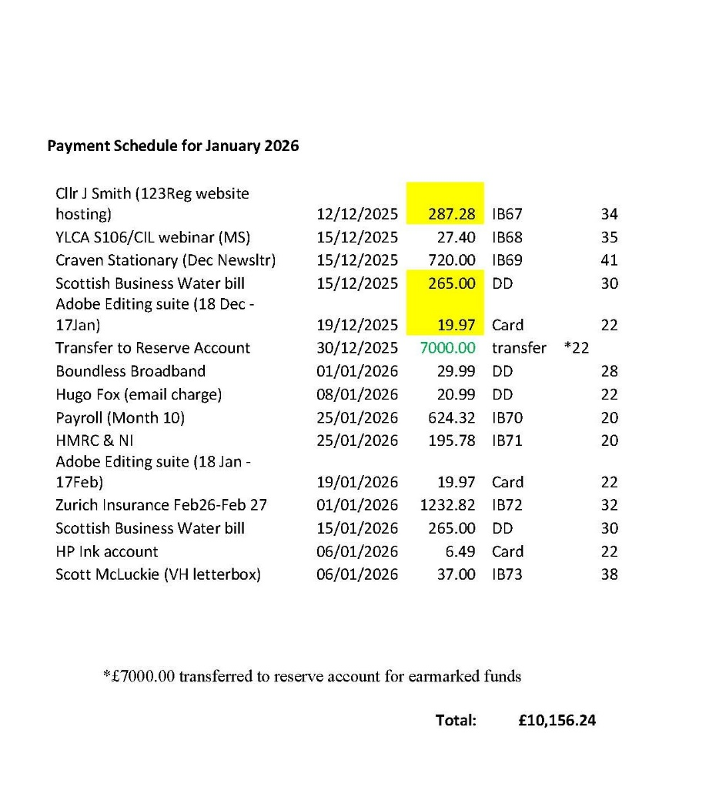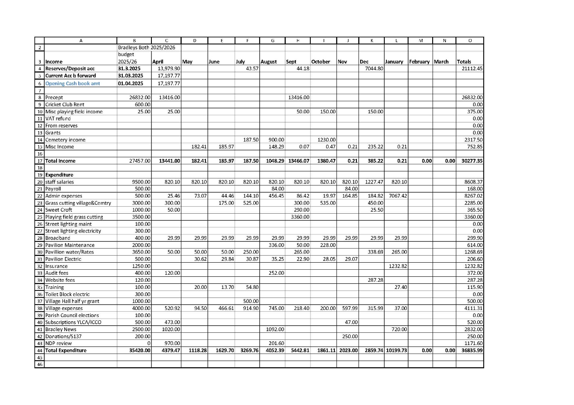
Agenda item 179.25 Accessibility Statement

Accessibility statement for bradleysboth-pc.gov.uk
This website is run by Bradleys Both Parish Council. We want as many people as possible to be able to use this website. For example, that means you should be able to:
- change colours, contrast levels and fonts using browser or device settings.
- zoom in up to 400% without the text spilling off the screen
- navigate most of the website using just a keyboard or speech recognition software.
- listen to most of the website using a screen reader (including the most recent versions of JAWS, NVDA and VoiceOver)
We’ve also made the website text as simple as possible to understand.
AbilityNet has advice on making your device easier to use if you have a disability.

How accessible this website is
We know some parts of this website are not fully accessible:
- you cannot modify the line height or spacing of text
- most older PDF documents are not fully accessible to screen reader software
- you cannot skip to the main content when using a screen reader
- there’s a limit to how far you can magnify the map on our ‘contact us’ page

What to do if you cannot access parts of this website
If you need information on this website in a different format like accessible PDF, large print, easy read, audio recording or braille:
- email clerk@bradleysboth-pc.gov.uk or call 07505 142383
We’ll consider your request and get back to you in 14 days.
Reporting accessibility problems with this website
We’re always looking to improve the accessibility of this website. If you find any problems not listed on this page or think we’re not meeting accessibility requirements, contact: clerk@bradleysboth-pc.gov.uk
Enforcement procedure
The Equality and Human Rights Commission (EHRC) is responsible for enforcing the Public Sector Bodies (Websites and Mobile Applications) (No. 2) Accessibility Regulations 2018 (the ‘accessibility regulations’). If you’re not happy with how we respond to your complaint, contact the Equality Advisory and Support Service (EASS).

Next
Agenda Item 181.25 Cricket Club
The cricket club have withdrawn Bradley 1st team from the league, following relegation a lot of players have left. This means that only the 2nd team will be playing on Saturday.
The sponsored team (who pay membership to Bradley CC) will still play on Sundays.

Richard asks how this will affect them? and...
Some of the teams in the league do not have their own grounds, could they play at Bradley?

The club are looking for a coach for junior players but haven't found one yet.

Agenda item 183.25
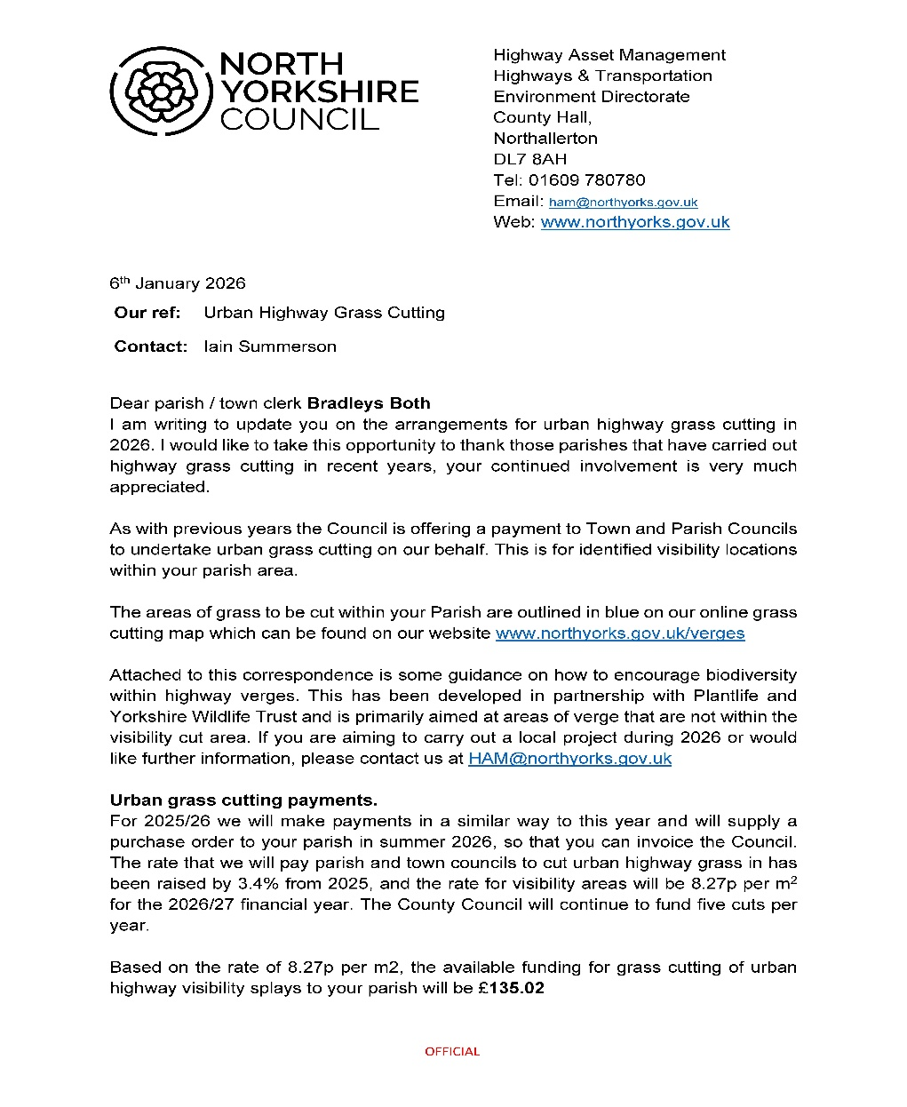

Deadline to agree 28th February 2026

End

